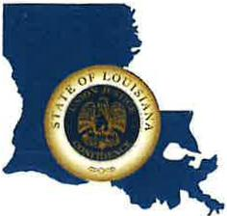 | CAPITAL AREA GROUNDWATER CONSERVATION DISTRICT
GARY I. BEARD
EXECUTIVE DIRECTOR

MEETING NOTICE
Capital Area Groundwater Conservation District
Technical Committee Meeting

WHEN: Wednesday, November 16, 2022

TIME: 1:00 p.m.

WHERE: Capital Area Groundwater Conservation District Office
3535 S. Sherwood Forest Blvd., Suite 137
Baton Rouge, LA 70816

Contact Person: Lisa Manda, (225) 293-7370

